RESTAURANT ORDERING & BILLING SYSTEM

Team Members:
- K. Varun Sai
- K. Prem Chandu
- Vinay
- D. Viswadha
- Ch. Sri Naga Divya

SUMMARY:
This project is a complete Restaurant Ordering and Billing System developed using Python and MySQL, designed to automate restaurant operations such as order taking, billing, discount handling, and revenue reporting. It supports multiple user roles — Manager, Admin, Waiter, and Cashier — each with distinct privileges and dashboard functionalities.
The Manager and Admin modules allow configuration of menus, taxes, discounts, and staff. They can add or deactivate users, track order histories, generate analytical sales reports, and export transaction data to CSV. Managers also manage discounts, view audit logs, and analyze performance reports such as daily sales, category-wise breakdowns, and top-selling dishes.
The Waiter and Cashier modules handle live operations — taking customer orders, modifying or closing orders, generating itemized bills with dynamic GST and discounts, and processing payments (cash, card, or UPI). Each transaction is logged with timestamps, staff details, and payment mode for accountability. The program also supports loyalty discounts, active promotions, and low-stock alerts.
Behind the scenes, the system leverages a normalized MySQL database with tables such as menu, orders, order_items, discounts, staff, and change_logs. This ensures strong relational integrity, proper tracking of all actions, and maintainable data structure.
Overall, the project demonstrates end-to-end integration of business logic, SQL operations, and data analytics, providing a realistic simulation of how restaurant POS and billing systems function in the real world.

ER DIAGRAM

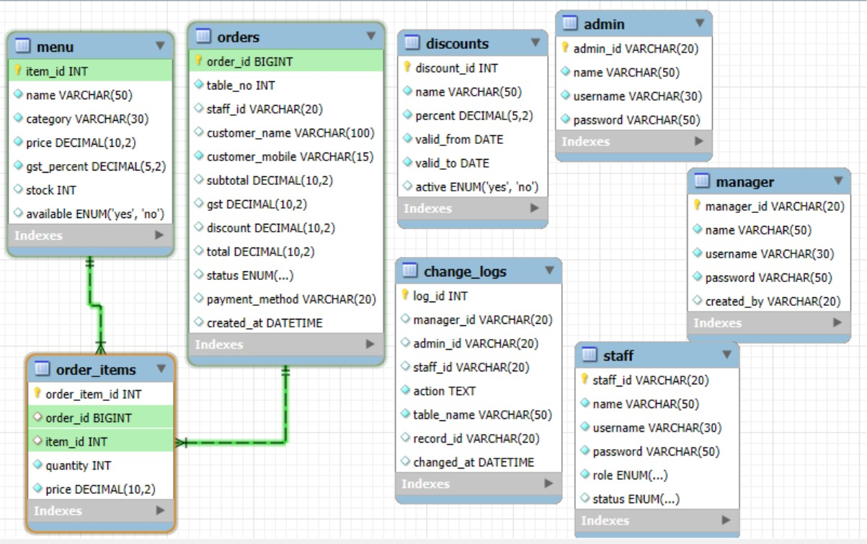

This ERD represents a restaurant management system that handles menu items, customer orders, staff, and administrative controls. The menu table stores information about each item, including name, category, price, stock, and availability. Customer purchases are tracked through the orders table, which records order details such as table number, staff member, customer info, totals, tax, discount, payment method, and order status. Each order can contain multiple menu items, which are detailed in the order_items table, linking individual items to an order along with quantity and price. Discounts that may apply to orders are managed in the discounts table, which defines discount names, percentages, validity periods, and active status.
User roles are divided into admin, manager, and staff tables, each storing login details, names, and role-specific identifiers. The system ensures accountability by logging all administrative or managerial actions in the change_logs table, which tracks who performed an action, on which table, and when. Overall, the ERD shows a well-structured system that supports restaurant operations, order processing, and user role management with clear relationships and auditability.

SQL SCRIPTS
CREATE
- CREATE TABLE manager (
manager_id VARCHAR(20) PRIMARY KEY,
name VARCHAR(50) NOT NULL,
username VARCHAR(30) UNIQUE NOT NULL,
password VARCHAR(50) NOT NULL,
created_by VARCHAR(20)
);

- CREATE TABLE admin (
admin_id VARCHAR(20) PRIMARY KEY,
name VARCHAR(50) NOT NULL,
username VARCHAR(30) UNIQUE NOT NULL,
password VARCHAR(50) NOT NULL
);

- CREATE TABLE staff (
staff_id VARCHAR(20) PRIMARY KEY,
name VARCHAR(50) NOT NULL,
username VARCHAR(30) UNIQUE NOT NULL,
password VARCHAR(50) NOT NULL,
role ENUM('waiter','cashier') NOT NULL,
status ENUM('active','inactive') DEFAULT 'active'
);

- CREATE TABLE menu (
item_id INT AUTO_INCREMENT PRIMARY KEY,
name VARCHAR(50) NOT NULL,
category VARCHAR(30) NOT NULL,
price DECIMAL(10,2) NOT NULL,
gst_percent DECIMAL(5,2) NOT NULL,
stock INT DEFAULT 0,
available ENUM('yes','no') DEFAULT 'yes'
) AUTO_INCREMENT=101;

- CREATE TABLE discounts (
discount_id INT AUTO_INCREMENT PRIMARY KEY,
name VARCHAR(50) NOT NULL,
percent DECIMAL(5,2) NOT NULL,
valid_from DATE NOT NULL,
valid_to DATE NOT NULL,
active ENUM('yes','no') DEFAULT 'yes'
) AUTO_INCREMENT=10101;

- CREATE TABLE orders (
order_id BIGINT AUTO_INCREMENT PRIMARY KEY,
table_no INT NOT NULL,
staff_id VARCHAR(20),
customer_name VARCHAR(100),
customer_mobile VARCHAR(15) NOT NULL,
subtotal DECIMAL(10,2) DEFAULT 0,
gst DECIMAL(10,2) DEFAULT 0,
discount DECIMAL(10,2) DEFAULT 0,
total DECIMAL(10,2) DEFAULT 0,
status ENUM('open','closed') DEFAULT 'open',
payment_method VARCHAR(20),
created_at DATETIME DEFAULT CURRENT_TIMESTAMP
) AUTO_INCREMENT=202500001;

- CREATE TABLE order_items (
order_item_id INT AUTO_INCREMENT PRIMARY KEY,
order_id BIGINT,
item_id INT,
quantity INT NOT NULL,
price DECIMAL(10,2) NOT NULL,
FOREIGN KEY (order_id) REFERENCES orders(order_id),
FOREIGN KEY (item_id) REFERENCES menu(item_id)
);

- CREATE TABLE change_logs (
log_id INT AUTO_INCREMENT PRIMARY KEY,
manager_id VARCHAR(20),
admin_id VARCHAR(20),
staff_id VARCHAR(20),
action TEXT NOT NULL,
table_name VARCHAR(50) NOT NULL,
record_id VARCHAR(20),
changed_at DATETIME DEFAULT CURRENT_TIMESTAMP
);

INSERT
- INSERT INTO manager (manager_id, name, username, password, created_by) VALUES
('Hydmanager001', 'Mithun', 'mithun', 'mithun123', NULL);

- INSERT INTO admin (admin_id, name, username, password) VALUES
('Hydadmin001', 'Vishu', 'vishu', 'vishu123'),
('Hydadmin002', 'Divya', 'divya', 'divya123');
- INSERT INTO staff (staff_id, name, username, password, role, status) VALUES
('Hyd0001', 'Chandu', 'chandu', 'chandu123', 'waiter', 'active'),
('Hyd0002', 'Vinay', 'vinay', 'vinay123', 'cashier', 'active'),
('Hyd0003', 'Sai', 'sai', 'sai123', 'waiter', 'active'),
('Hyd0004', 'Varun', 'varun', 'varun123', 'cashier', 'active'),
('Hyd0005', 'Divya', 'divya', 'divya123', 'waiter', 'inactive');

- INSERT INTO menu (name, category, price, gst_percent, stock, available) VALUES
('Paneer Butter Masala', 'Main Course', 250.00, 5.00, 20, 'yes'),
('Veg Biryani', 'Main Course', 180.00, 5.00, 15, 'yes'),
('Gulab Jamun', 'Desserts', 60.00, 5.00, 30, 'yes'),
('Cold Coffee', 'Beverages', 90.00, 5.00, 3, 'yes'),
('French Fries', 'Starters', 120.00, 5.00, 10, 'yes'),
('Chicken Curry', 'Main Course', 300.00, 5.00, 8, 'yes');

- INSERT INTO discounts (name, percent, valid_from, valid_to, active) VALUES
('Weekend Offer', 10.00, '2025-01-01', '2025-12-31', 'yes'),
('Festive Special', 15.00, '2025-10-01', '2025-10-31', 'yes'),
('New Year Blast', 25.00, '2025-12-25', '2026-01-05', 'yes'),
('Summer Delight', 5.00, '2025-04-01', '2025-06-30', 'no');

SELECT
- SELECT name, price, gst_percent, stock, available FROM menu WHERE item_id=101;
- SELECT item_id, name, category, price, gst_percent, stock, available FROM menu;
- SELECT staff_id, name FROM staff WHERE status='inactive';
- SELECT staff_id FROM staff ORDER BY staff_id DESC LIMIT 1;
- SELECT staff_id, name, role FROM staff WHERE username=%s AND password=%s AND status='active'", (u, p));

UPDATE
UPDATE staff SET status='inactive' WHERE staff_id=HYD003;
UPDATE menu SET price=120, gst_percent=5, stock=4, available=’yes’ WHERE item_id=101;
UPDATE menu SET available='no' WHERE item_id=102;
UPDATE menu SET available=’no’ WHERE item_id=103;
UPDATE order_items SET quantity = quantity + stock WHERE order_id = 202500001 AND item_id = 104;
QUERIES USING JOIN, GROUP BY, HAVING:

Top 10 Most Ordered Dishes
SELECT m.name AS Item, SUM(oi.quantity) AS Total_Qty,
SUM(oi.price * oi.quantity) AS Revenue
FROM order_items oi
JOIN menu m ON oi.item_id = m.item_id
JOIN orders o ON o.order_id = oi.order_id
WHERE o.status = 'closed' GROUP BY m.name ORDER BY Total_Qty DESC LIMIT 10
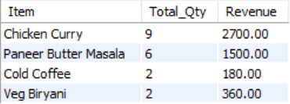

Category-wise Sales Breakdown
SELECT m.category,
SUM(oi.quantity) AS Total_Items_Sold, SUM(oi.price * oi.quantity) AS Total_Revenue
FROM order_items oi
JOIN menu m ON oi.item_id = m.item_id
JOIN orders o ON o.order_id = oi.order_id
WHERE o.status = 'closed' GROUP BY m.category ORDER BY Total_Revenue DESC
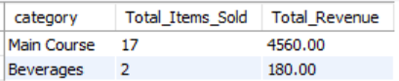

Daily Total Sales Report
SELECT DATE(o.created_at) AS Date,
COUNT(o.order_id) AS Orders, SUM(o.total) AS Total_Sales FROM orders o
WHERE o.status = 'closed' GROUP BY DATE(o.created_at) ORDER BY Date DESC
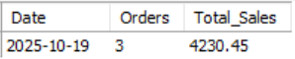

Monthly Revenue Summary
SELECT DATE_FORMAT(o.created_at, '%Y-%m') AS Month,
COUNT(o.order_id) AS Orders, SUM(o.total) AS Total_Revenue
FROM orders o WHERE o.status = 'closed' GROUP BY Month ORDER BY Month DESC
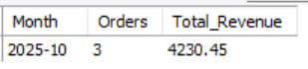

Staff-wise Sales Performance
SELECT s.name AS Staff, s.role AS Role,
COUNT(o.order_id) AS Orders_Handled, SUM(o.total) AS Total_Revenue FROM orders o
JOIN staff s ON o.staff_id = s.staff_id WHERE o.status = 'closed'
GROUP BY s.name, s.role ORDER BY Total_Revenue DESC
